Revised 04/14/2021

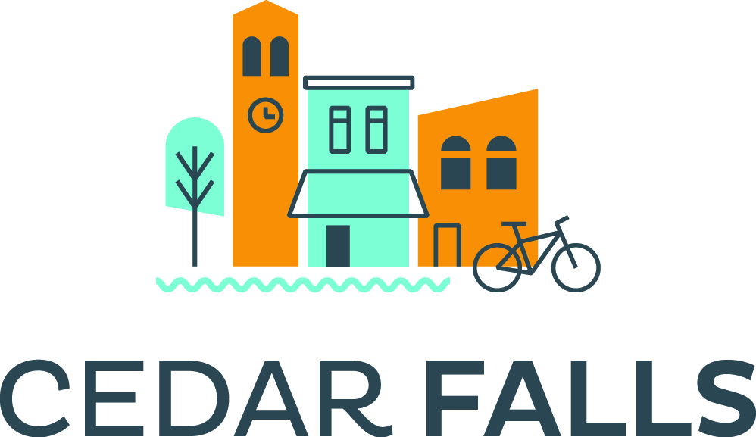
Tourism Development and
Marketing Grant
Application

Purpose:
The City of Cedar Falls Tourism & Visitors Bureau offers grants to be used to attract, develop, or promote an event, meeting or convention, sporting competition, special project or attraction that will bring visitors to
Cedar Falls, thereby increasing overnight stays in area hotels and/or tourism spending.

Applications:
Applications for financial assistance can be submitted to the Cedar Falls Tourism and Visitors Bureau at any time until funds for the year are depleted. Applications MUST be received at least 90 days prior to your intended project.

Eligible Applications/Expenses:
Eligible expenses are limited to events, attractions and projects that create overnight stays and/or encourage tourism-related economic activity in Cedar Falls.

Items that may be funded include:
- design and/or production and mailing of brochures, postcards, fliers, and posters
- digital marketing and social media campaigns that reach outside of the county
- advertising, design and placement in media outlets that reach outside of the county
- web site development, bid fees, venue and equipment rental, entertainment, performance fees, travel show materials and booth fees, shuttle service

If you have questions about eligible projects, please call the bureau at any time.

General Instructions:
Grant application must be typewritten with a full description of the organization making the request, the project or event date if applicable, and a complete, itemized description of how funding will be used. Sketches or mock-ups are helpful, and bids or price estimates are required. If you are seeking funding for advertising, please include a draft of your intended message, target audience and media outlets.

All projects must contain the tagline “This project sponsored in part by the Cedar Falls Tourism and Visitors Bureau”, and our logo and web site, which is www.CedarFallsTourism.org. Digital art will be supplied upon request. Funding is made available in the form of reimbursement.

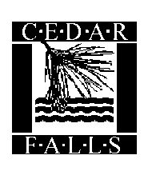
Applicants who receive funding will be expected to track visitor attendance and hotel usage and provide a full accounting of approved expenditures and a brief evaluation of the event or project within thirty days after its completion. A form will be provided for this evaluation.
10/02/2020

TOURISM DEVELOPMENT AND MARKETING GRANT APPLICATION

Date of Application:

Date of Event/Project:
Project Name/Title:

Contact Person:

Organization:

Address:

Telephone: E-mail:

- Project Description:

2. How will your project bring visitors to our community?

3. How much money are you requesting?

4. Please indicate specifically how the monies will be spent and attach vendor bids or estimates.
If you are advertising, include intended media outlets with pricing and target audience. Bids and/or price estimates supplied by your vendor(s) are required. Photos, sketches or mock-ups are also helpful.

5. Are you receiving additional grants or funding from other sources? If so, from whom and how much?

6. Please provide an overall budget for your event.

7. If this request is for advertising assistance, how did you make your media/vendor choices?

8. Do you have plans for additional advertising beyond that outlined in the above question? Please share your overall marketing plans.
9. How would your project be affected if you would not receive funding from the Tourism and Visitors Bureau or if you would receive less than you requested?

10. How many participants do you anticipate and for how long?

11. How many will travel at least 50 miles to attend?

12. How did you arrive at this figure?

13. From where do you anticipate these visitors will come and why?

14. What actions will you take or how will you obtain this information so a report can be made after your event/project.

15. Will other lodging opportunities be offered?
(ie: camping, home stays, dorms, etc.)

16. Has this event taken place in Cedar Falls before?

17. If not, was it held elsewhere? If so, where and how many lodging nights were generated?

18. Will this be an annual project?

19. How is your organization improving or enhancing the event from the last time it was hosted?

20. Is there potential for this event to grow? If so, how?

21. What would you say is the most compelling reason for the bureau to financially support your project?

22. What other Visitor Bureau services will you request to create a successful event?
o Registration Assistance o Visitor Bags/Folders
o Assistance in securing a room block o Information Table
o Assistance with planning tours and special activities o Mailings
o Pre-Event Emails o VIP Welcome

______________________________________
Signed by: Dated:

PLEASE FEEL FREE TO ATTACH ADDITIONAL INFORMATION, SAMPLES, ETC. THAT MAY
SUPPORT YOUR APPLICATION AND RETURN TO:

Cedar Falls Tourism and Visitors Bureau
6510 Hudson Road, Cedar Falls, Iowa 50613
kim@cedarfallstourism.org
(319) 268-4266 (800) 845-1955 Fax (319) 277-9707

Since funding from this grant program is uncertain, please do not rely on this grant as part
of your annual operating budget. Application with incomplete information may jeopardize funding.

Grants\Forms

