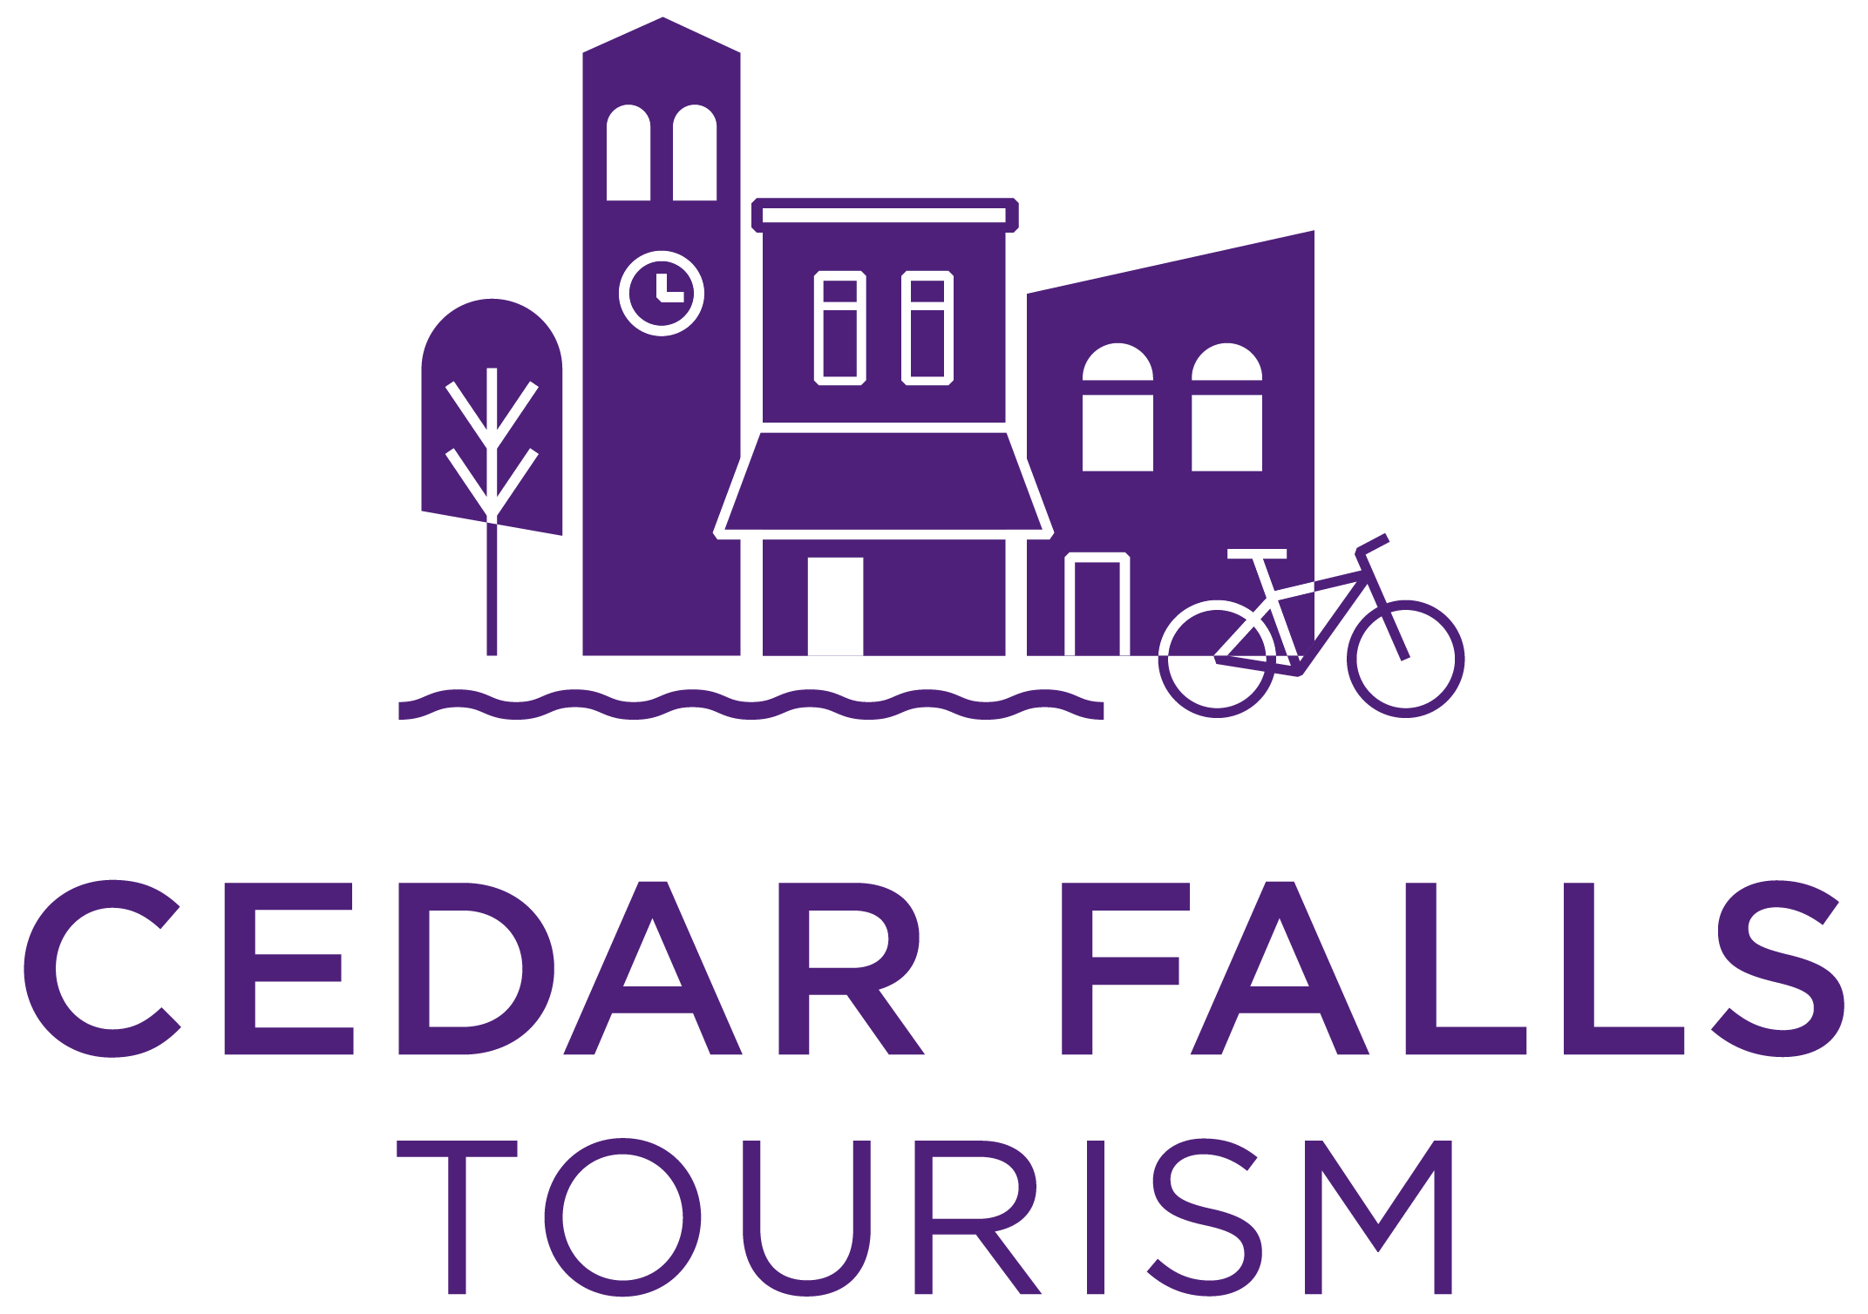

Post Event/Project Evaluation

Contact:
Event/Project Description:

Event Date(s):
Was your event/project successful? How do you measure this?

Estimated Event Attendance Overall: Number of visitors from 50+ miles away: ____________
From where did they come?
How did you arrive at these figures?
Is there potential for this event to grow in the future and if so, how?

Facility(ies) Used:
Were you satisfied with the facility and service(s)? ___ Yes ___ No Comments:

Hotel(s) Used:

Number of lodging nights created by your event/project:
(number of rooms x number of nights)
How did you determine this?

Were you satisfied with the facility and service(s)? ___ Yes ___ No Comments:

What services did Cedar Falls Tourism provide for this event/project?

Were you satisfied with these services? ___ Yes ___ No Comments:

Do you plan to hold your event/project in Cedar Falls again? ___ Yes ___ No
When?
Do you believe our financial assistance helped increase the number of out-of-town visitors that came to your event or as a result of your project?

Are there any additional comments you wish to make?

**Please attach copies of your invoices and send examples of how you recognized Cedar Falls Tourism.

